## **1. Write a program that takes radius of a circle as input. Read the entered radius**

## **using Scanner class. Then calculate and print the area and circumference of**

## **the circle**

import java.util.Scanner;

class don{

public static void main(String[] args)

{

float r, circum;

Scanner s = new Scanner(System.in);

System.out.print("Enter the Radius of Circle: ");

r = s.nextFloat();

circum = (float)(2*3.14*r);

System.out.println("\nCircumference = " +circum);

}

}

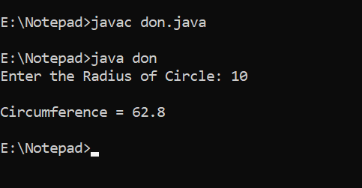

**2. Write a program to calculate sum of 5 subject’s marks &amp; find percentage. Take**

**the obtained marks from user using Scanner class. Output should be in this**

**format [ percentage marks = 99 % ]. Use concatenation operator here.**

import java.util.Scanner;

class ban {

public static void main(String[] args) {

Scanner in = new Scanner(System.in);

System.out.println("Enter the marks of five subjects:\n");

float sub1 = in.nextFloat();

float sub2 = in.nextFloat();

float sub3 = in.nextFloat();

float sub4 = in.nextFloat();

float sub5 = in.nextFloat();

float total = sub1 + sub2 + sub3 + sub4 + sub5;

float percentage = (float)((total / 500.0) * 100);

System.out.println("The Percentage = " + percentage + "%");

}

}

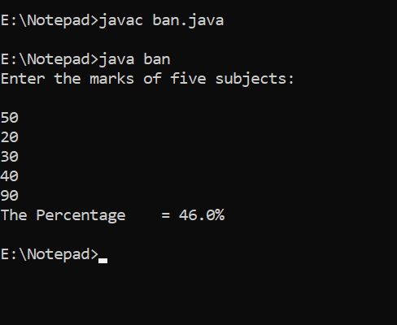

**3. Write a program to find the simple interest. Take the principle amount, rate of**

**interest and time from user using Scanner class.**

import java.util.Scanner;

class SI {

public static void main(String[] args) {

Scanner sc = new Scanner(System.in);

System.out.print("Enter the principal: ");

double principal = sc.nextDouble();

System.out.print("Enter the rate: ");

double rate = sc.nextDouble();

System.out.print("Enter the time: ");

double time = sc.nextDouble();

double interest = (principal * time * rate) / 100;

System.out.println("Simple Interest: " + interest);

}

}

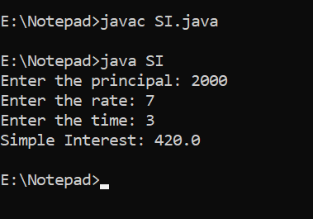

**4. Write a program to read the days (eg. 670 days) as integer value using**

**Scanner class. Now convert the entered days into complete years, months**

**and days and print them.**

import java.util.Scanner;

class day{

public static void main(String args[]){

Scanner sc = new Scanner(System.in);

System.out.print("Enter the number of days: ");

int days = sc.nextInt();

int year,month,day,tp;

year = days/365;

tp = days%365;

month = (tp)/30;

tp = tp%30;

day = tp;

System.out.println(year+" years,"+month+" months and "+day+"days");

}

}

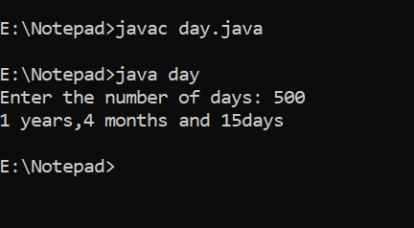

**5. Write a program to convert temperature from Fahrenheit to Celsius. Take**

**Fahrenheit as input using Scanner class. [ formula : C= 5*(f-32)/9 ]**

import java.util.Scanner;

class Temperature {

public static void main(String[] args)

{

double celsius, fahrenheit;

Scanner s = new Scanner(System.in);

System.out.print("Enter temperature in Fahrenheit:");

fahrenheit = s.nextDouble();

celsius = (fahrenheit-32)*(0.5556); // [ formula : C= 5*(f-32)/9 ]

System.out.println("Temperature in Celsius:"+celsius);

}

}

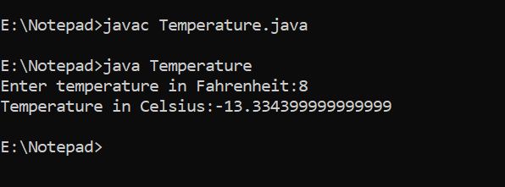

**6. Write a program to swap two numbers without using third variable.**

import java.util.Scanner;

class Swap{

public static void main(String a[]){

System.out.println("Enter the value of k and p");

Scanner sc = new Scanner(System.in);

int k = sc.nextInt();

int p = sc.nextInt();

System.out.println("before swapping numbers: "+k +" "+ p);

//Swapping

k = k + p;

p = k - p;

k = k - p;

System.out.println("after the swap: "+k +" " + p);

}

}

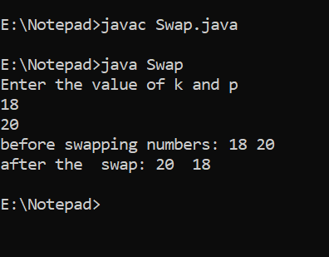

**7. In a company an employee is paid as under: If his basic salary is less than Rs.**

**10000, then HRA = 10% of basic salary and DA = 90% of basic salary. If his**

**salary is either equal to or above Rs. 10000, then HRA = Rs. 2000 and DA =**

**98% of basic salary. If the employee&#39;s salary is input by the user write a**

**program to find his gross salary. [ formula : GS= Basic + DA + HRA ]**

import java.util.Scanner;

class Salary{

public static void main(String args[]) {

float bs, gs, da, hra;

System.out.println("Enter basic salary:");

Scanner sc = new Scanner(System.in);

bs=sc.nextFloat();

if (bs<10000)

{

hra=bs*10/100;

da=bs*90/100;

}

else

{

hra=2000;

da=bs*98/100;

}

gs=bs + hra + da;

System.out.println("Gross Salary = " +gs);

}

}

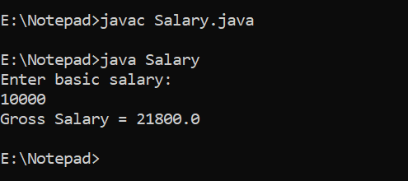

**8. Program to find greatest in 3 numbers. [ once using if else statement and then**

**using ternary operator ( logical operator) ]**

import java.util.Scanner;

class really {

public static void main(String[] args)

{

Scanner sc=new Scanner(System.in);

System.out.print("Enter the value of X= ");

int x=sc.nextInt();

System.out.print("Enter the value of Y= ");

int y=sc.nextInt();

System.out.print("Enter the value of Z= ");

int z=sc.nextInt();

if(x>y && x>z)

{

System.out.println("X is greatest");

}

else if(y>x && y>z)

{

System.out.println("Y is greatest");

}

else if(z>x && z>y)

{

System.out.println("Z is greatest");

}

else if(z==x || x==y || y==z)

{

System.out.println("all are same");

}

}

}

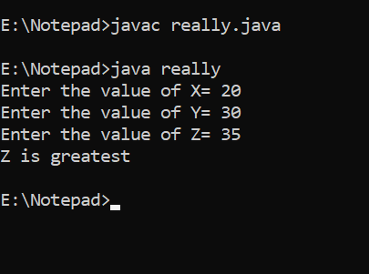

**9. Program to check that entered year is a leap year or not.**

import java.util.Scanner;

class LeapYear{

public static void main(String[] args) {

int year;

Scanner scan = new Scanner(System.in);

System.out.println("Enter any Year:");

year = scan.nextInt();

if (year % 400 == 0) {

System.out.println(year + " is a leap year.");

}

else if (year % 100 == 0) {

System.out.println(year + " is not a leap year.");

}

else if (year % 4 == 0) {

System.out.println(year + " is a leap year.");

}

else {

System.out.println(year + " is not a leap year.");

}

}

}

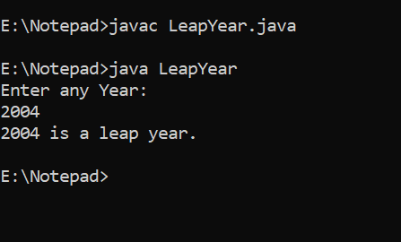

**10. Accept person’s gender (character m for male and f for female), age (integer),**

**as input and then check whether person is eligible for marriage or not.**

import java.util.Scanner;

class gender {

public static void main(String[] args)

{

Scanner sc=new Scanner(System.in);

System.out.println("Enter Gender = ");

char gender=sc.next().charAt(0);

System.out.println("Enter Age = ");

int age=sc.nextInt();

if((gender=='M' ||gender=='m')&&(age>=21)){

System.out.println("Congratulations man you are eligible for marriage");}

else

if((gender=='F' ||gender=='f')&&(age>=18))

{System.out.println("Congratulations girl you are eligible for marriage");}

else

{System.out.println("sorry you are not eligible for marriage");}

}

}

